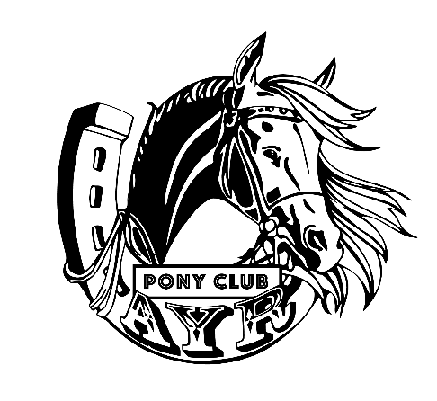
OPEN SHOWJUMPING
Saturday 12th September 2026

AYR PONY AND HACK CLUB

Venue: Ayr Pony Club Grounds, Lower Wickham St, Ayr. PIC QJBZ0107
Start Time: 9.00am
Entry Fee: $30/ horse rider combination.
Class 9: Encouragement Class: $10
All non PCQ riders MUST pay $20.00 insurance fee and sign a liability declaration form and day participant waiver form before competing.
Contact/enquiries: Dee Formilan ayrponyandhackclub@gmail.com 0439746639
Nominations: All nominations are via the My Pony Club Just Go website. Pre-nominate by Wednesday 9th September.
Late nominations will incur a $10 late fee.
Canteen: Available all day, Eftpos available!
Camping: Non-Powered: $20/site, Powered $25 (limited).
Dress Code: Long sleeve shirt with tie or ratcatcher collar, cream or white jodhpurs or jeans.
Course builders/Judges Andrew Gilchrist and Tracey Hopkins
All events run under 2025 PCQ Showjumping Rules and PCA 2025 National Gear Rules.

Events:
AM7 (art 238 – 2.4. Opt B)
AM5 (art 238 – 2.2)
Super2Phase (art 274-2-5.6)

Program
Class 1 – 12 years & Under 60cm
Class 2 – 12 years & Under 70cm
Class 3 – 12 years & Under 80cm
Class 4 – 13-26 years 70cm
Class 5 – 13-26 years 80cm
Class 6 - 13-26 years 90cm
Class 7 - 13-26 years 100cm
Class 8 - 13-26 years 110cm
Class 9 – Encouragement Cross Rails
Class 10 – 12 years & under 40-50cm
Class 11 – Over 12 years 50-60cm
Class 12 – Seniors Choose height (only eligible for award if nominated 70cm or over)
Pony Club members can count as a qualifying event for next year's championships.
Riders may present a performance card for Classes 1-8

AWARDS
Champion and Reserve Champion rider for each class.
Ribbons to 5th place in each event.
Class 9 receives a gift bag.

PAIRS TWILIGHT FEATURE EVENT

.

TERMS AND CONDITIONS
Dress Code: Long sleeve shirt with tie or ratcatcher collar, cream or white jodhpurs or jeans

RESERVATION OF RIGHTS
The organising committee reserves the right to; cancel any class or event, combine or divide classes according to the numbers nominated and the rules governing splitting of groups, alter advertised times, transfer competitors between sections of a class and to refuse any entry with or without stating a reason.

DISCLAIMER: Neither the organising committee of this event nor PCAQ accepts any liability for the damage, accident, injury or illness to horses, riders, spectators or any other persons or property whatsoever.

The final responsibility for the suitability of the mount, saddlery and equipment rests with the Rider or their responsible adult. (see General Rules).

Protests: Should be lodged within 30 minutes of the results being posted, or the incident and should be accompanied by $50 fee which is refundable only if the protest is upheld. Each club is to nominate a delegate at start of competition to form disputes committee.

PCAQ Rules apply to this Event: Competitors must be current financial members of PCAQ.

HELMETS: Equestrian helmet AS/NZS 3838, EN 1384 or ASTM F1163, with an effective chin strap. Riders with unstamped helmets of the required specification will not be expected to replace them. For competition – only black, brown, navy blue & white are allowed.
The Helmet must be worn whenever mounted under Pony Club supervision, including to & from the Pony Club - this includes seniors & instructors. Candidates at Instructor Schools must wear helmets. Mounted Voluntary Helpers must wear the regulation headgear.

Riders must keep helmets on during Mounted Presentation of Awards & while saluting.

FACE GUARDS Allowed on ASA equestrian helmets.

HELMET COVER Detachable Helmet Covers are permitted in Mounted Games & Cross Country only in combination of shirt and tie colours of club/zone. Black, brown, navy blue and white can be worn in any competition.

SUNSHADE/SUN PROTECTOR Can be worn over or under helmet.

One senior official from each club to form a Dispute Committee, nominee to be lodged with entries. The committee’s decision will be final.

Horse Health Declarations (HHD) required on the day of the event - NO HHD NO Ride

From 1st January 2018, the competitive horse rule currently exists for Show Jumping will be applied to ODE, Dressage and Combined Training at the discrection of the organizing committee riders may enter 2 horses in the following way: Riders may enter 2 horses in the same or different heights. Each horse may gain qualifying results. Each horse will be placed and is eligible for overall awards.

Dogs must be kept on a lead.
DOGS ARE TO BE RESTRAINED AT ALL TIMES AND MUST REMAIN AT YOUR CAMP/FLOAT.

